BUSINESS INFORMATION REQUIREMENTS

IFT 323(DATABASE DESIGN AND PROGRAMMING)

Timetable Scheduling Management System

GROUP 12

GROUP 12 MEMBERS
- BENSON CHARLES KELECHUKWU 23/2710
- DOUMU EBIWENI DANIEL 23/2523
- ALUKO MAYOWA SAMUEL 23/2477
- HENRY TIMOTHY ISAIAH 232550
- AMINU AL-AMIN MOSOPEFOLUWA ADEJARE 23/1214

Introduction
The Timetable Scheduling Management System (TSMS) is designed to automate the process of generating, viewing, and managing academic timetables. It replaces manual scheduling with a structured, database-driven solution that ensures accuracy, conflict detection, streamlined operations, and secure access for administrators, lecturers, and students.
This documentation outlines the business information needs that the system must fulfil based on the analyzed project files, database structure, and existing source code.

Purpose
To centralize and digitize timetable creation, ensuring accurate scheduling and reducing conflicts.
Key Objectives
- Automate timetable scheduling processes.
- Allow administrators to input and manage academic data.
- Provide an organized view of scheduled classes.
- Enable students and staff to view generated timetables.
Expected Benefits
- Reduction in manual timetable errors.
- Faster updates and timetable generation.
- Improved data consistency across academic units.
Scope
The system manages user authentication, CRUD operations for departments, courses, lecturers, rooms, timeslots, and timetable scheduling.

Business Context
Background
Academic institutions traditionally use manual or spreadsheet-based methods for scheduling, which are prone to conflicts and inefficiency.
Pain Points
- Manual scheduling clashes
- Data inconsistency
- No centralized view of timetable
Business Drivers
- Efficiency
- Real-time updates
- Centralized consistency
Constraints
- Web-based access
- Database-driven
- Authentication required

Business Objectives
- Automate timetable creation for departments, lecturers, courses, and rooms.
- Eliminate scheduling conflicts (room clashes, lecturer clashes, course clashes).
- Centralize academic scheduling data into a relational database.
- Provide quick access for students and lecturers to view updated timetables.
- Enable secure authentication through a login/signup system.
- Support administrative tasks such as adding courses, lecturers, rooms, and timetable entries.

Stakeholders
Stakeholder | Information Needs
Admin | Manage lecturers, rooms, departments, courses, timeslots, and timetable entries. Run reports. Resolve scheduling conflicts.
Lecturers | View personal weekly timetable, course assignments, and allocated rooms.
Students | View department timetable and updated schedules.
Developers | Maintain database, update system, ensure availability/security.

Functional Requirements
1. Authentication & Security
- Ability for users to sign up and log in (login.php, signup.php)
- Validate credentials via database (db_connect.php)
- Maintain session-based security (auth_check.php)
- Allow logout functionality (logout.php)

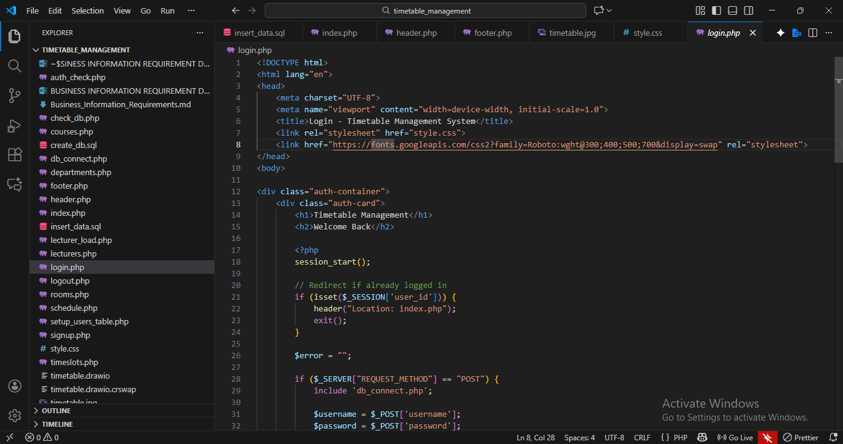
(login.php)

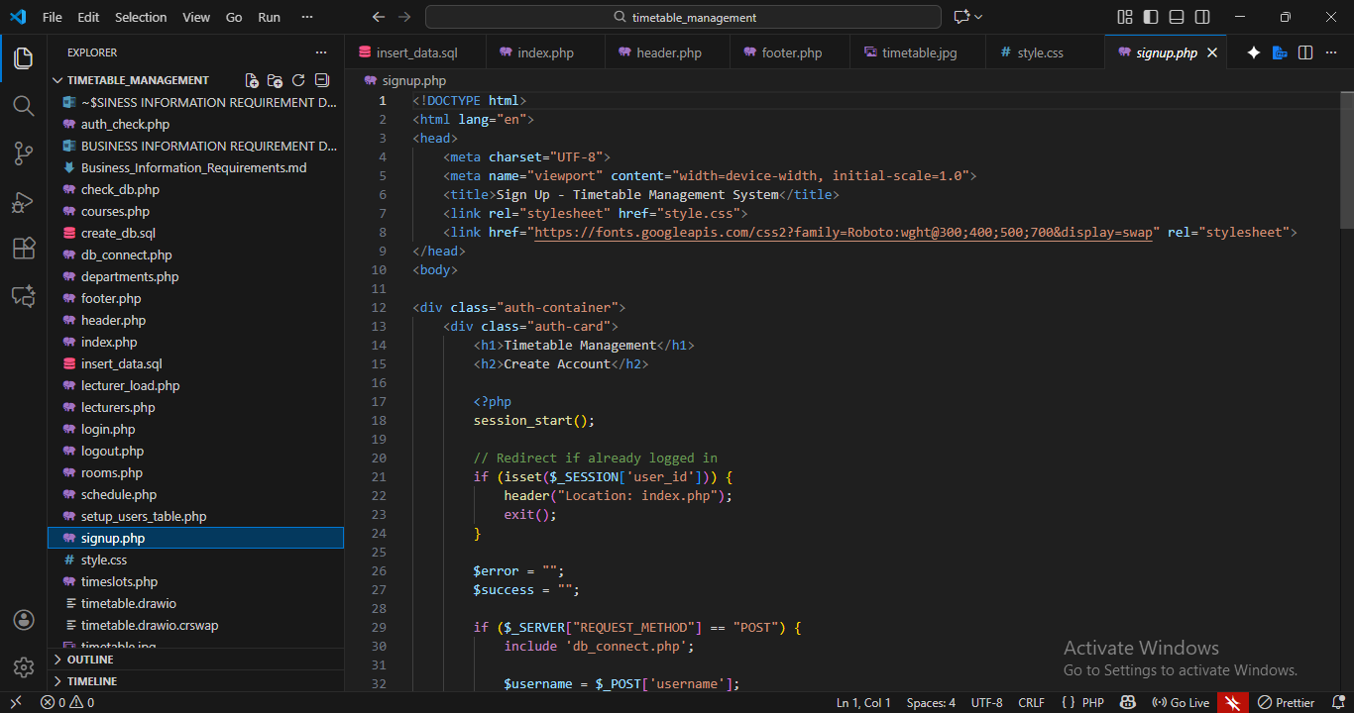
(signup.php)

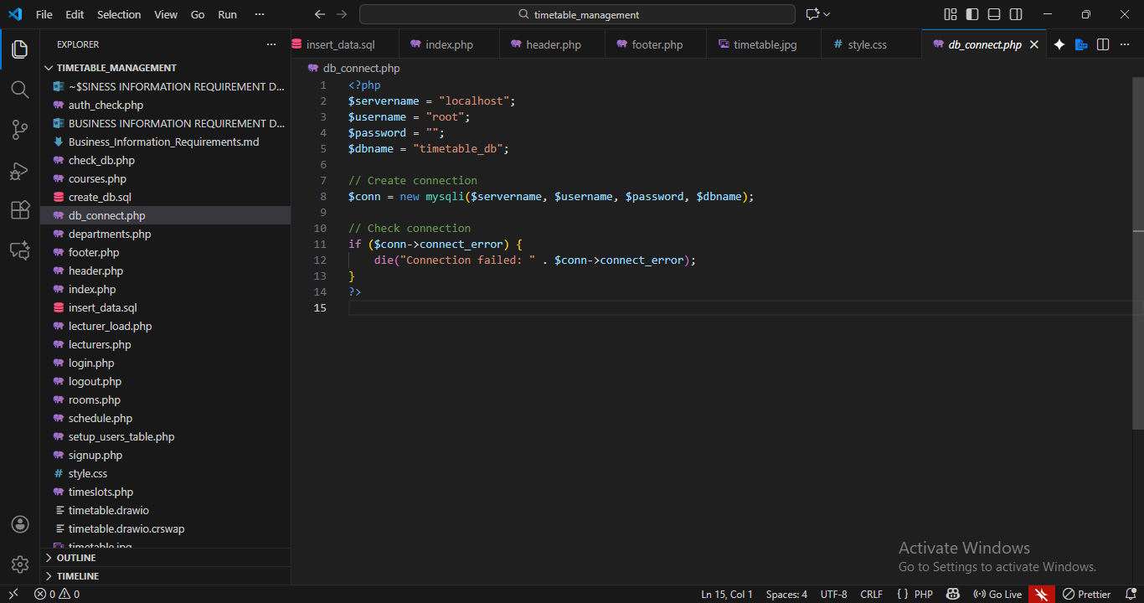
(db_connect.php)

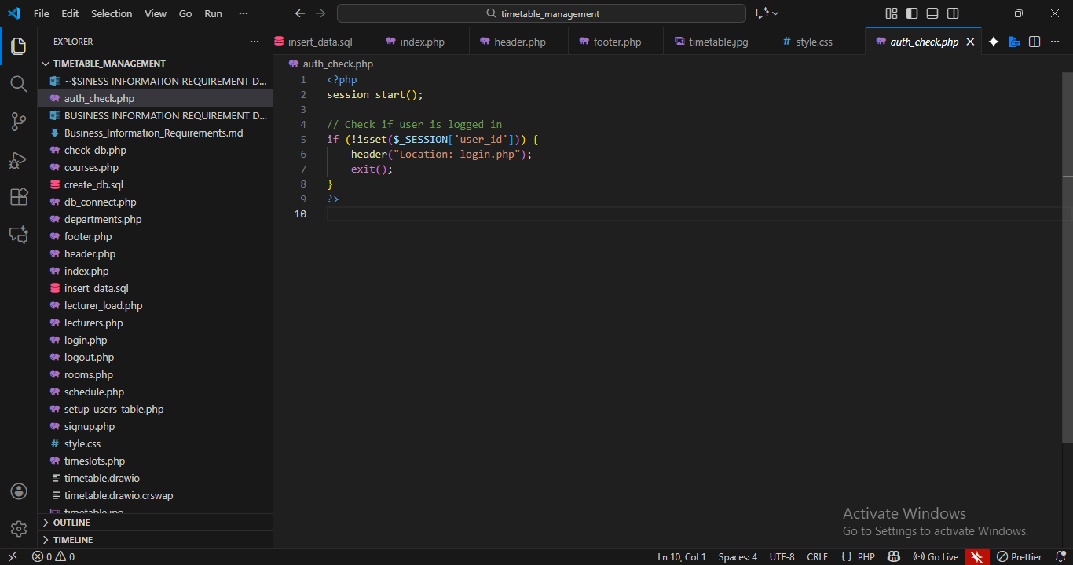
(auth_check.php)
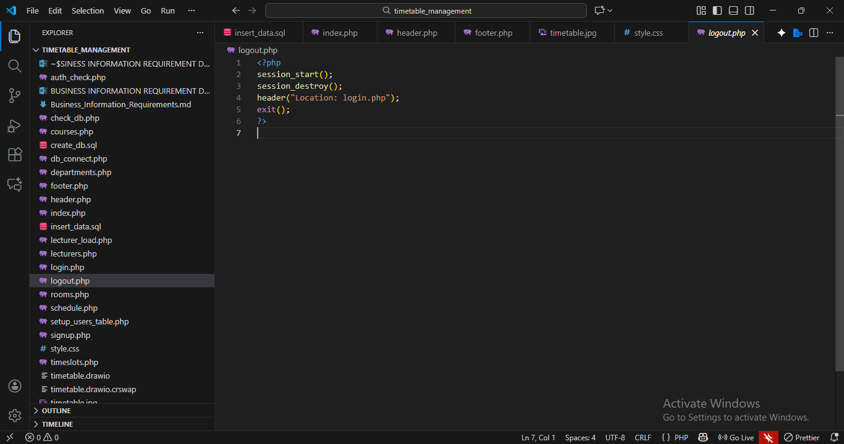
(logout.php)

2. Department Management
- Add / view / update departments (departments.php)
- Assign courses and lecturers to departments

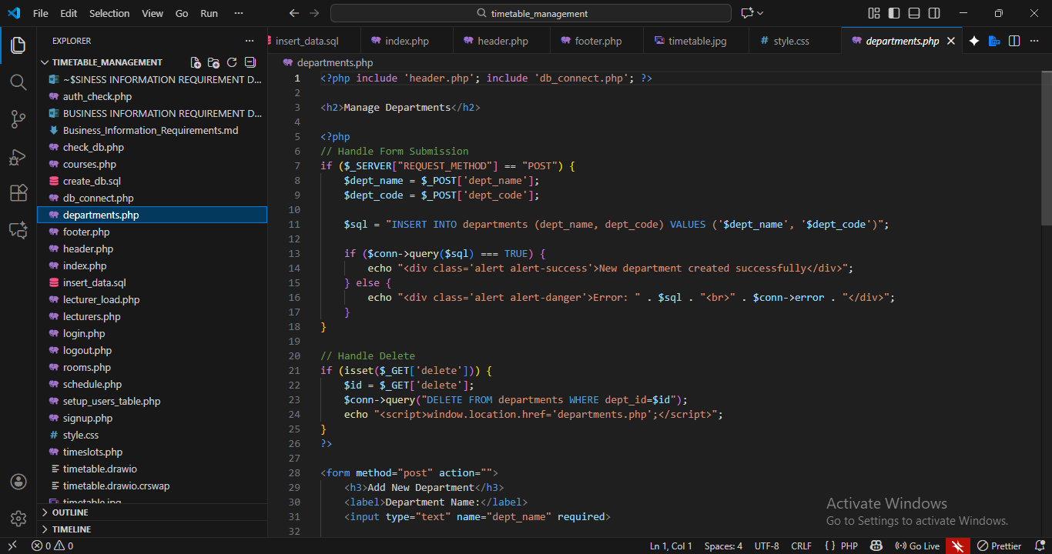
(departments.php)

- Course Management
- Add / view / update courses (courses.php)
- Link each course to a department and lecturer
- Store course codes, titles, and credit load

4. Lecturer Management
- Add / update lecturer details (lecturers.php)
- Assign lecturer teaching loads (lecturer_load.php)
- Prevent lecturer timetable conflicts

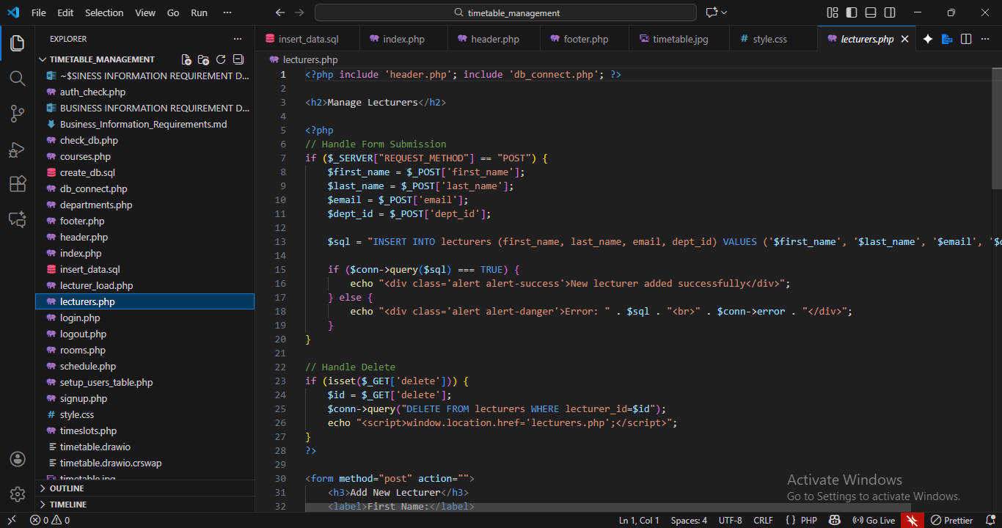
(lecturers.php)

5. Room Management
- Add and manage available rooms (rooms.php).
- Store attributes such as room number and capacity

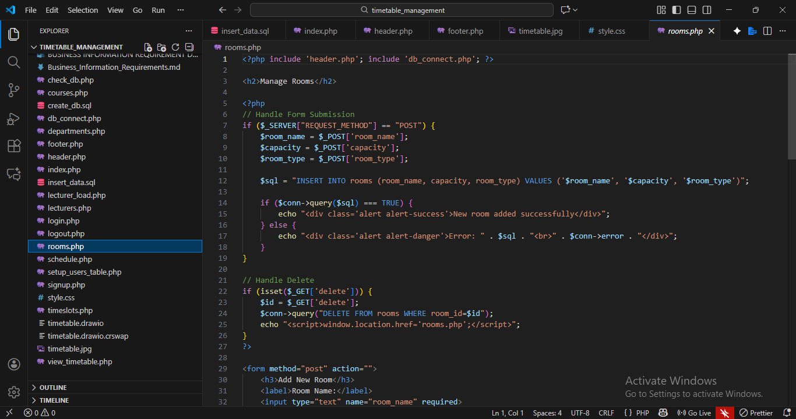
(rooms.php)

6. Time Slot Management
- Add and manage teaching periods (timeslots.php)
- Define days of the week and associated time blocks

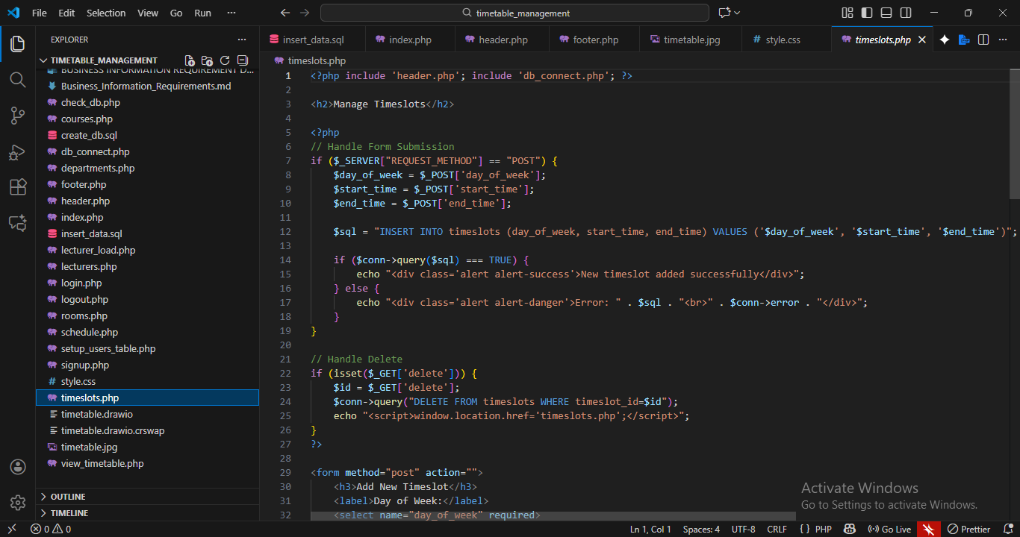
(timeslots.php)

7. Timetable Scheduling
- Insert timetable entries (schedule.php)
- Select course, lecturer, room, department, and time slot
- Detect and prevent clashes:
Lecturer cannot be in two classes at once
A room cannot host more than one class at a time
A course cannot be double-booked
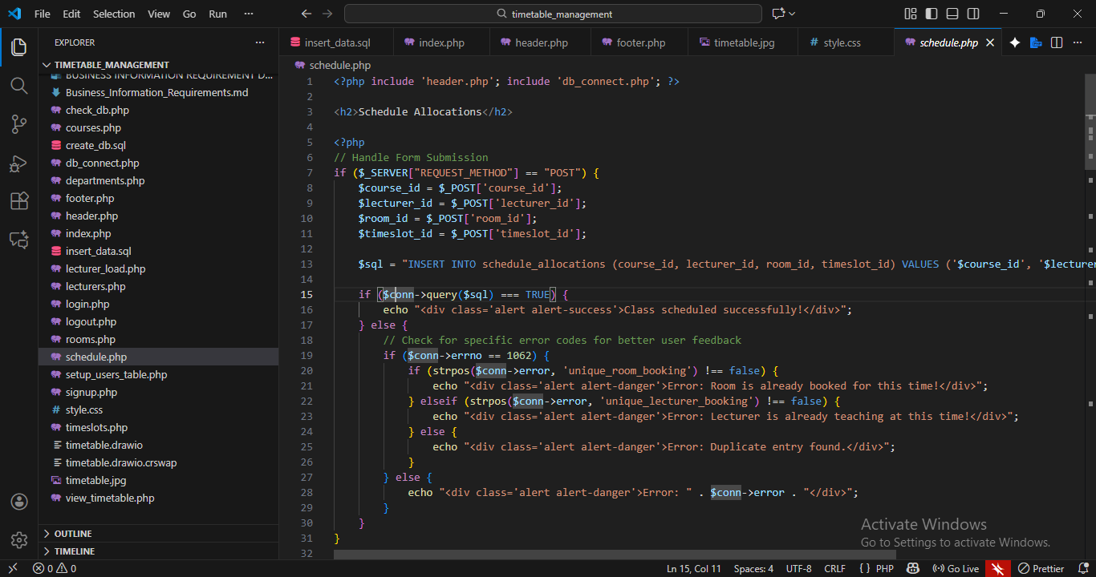
(schedule.php)

- Timetable Viewing
- View full timetable (view_timetable.php)
- View by:
Department
Lecturer
Course
Day of the week

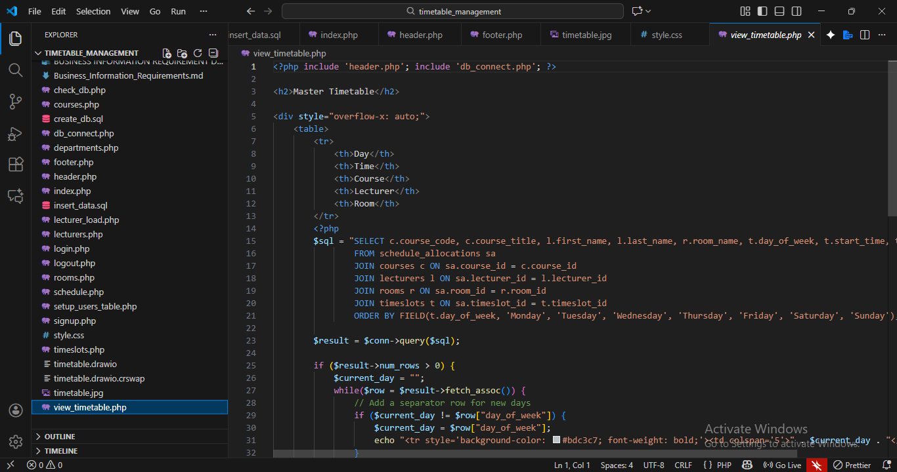
(view_timetable.php)

9. Data Storage Requirements
- The system must store:
Users
Lecturers
Departments
Rooms
Courses
Timeslots
Timetable entries
Authentication metadata
The SQL files (create_db.sql, insert_data.sql) are used in creating the database

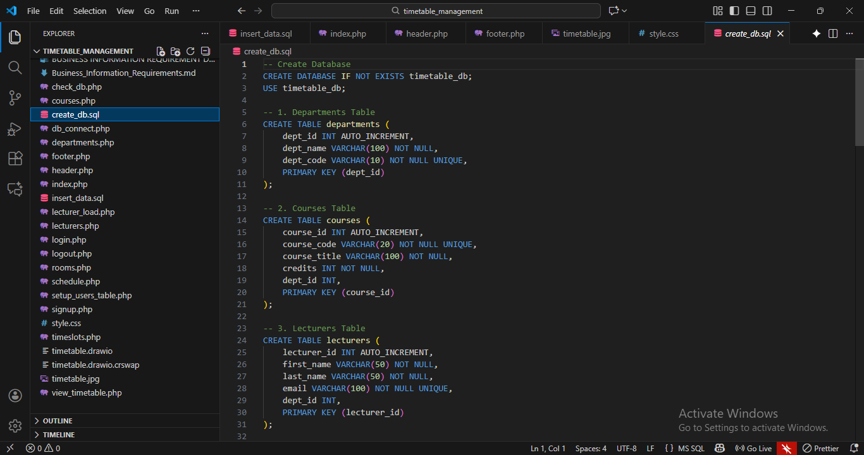
(create_db.sql)

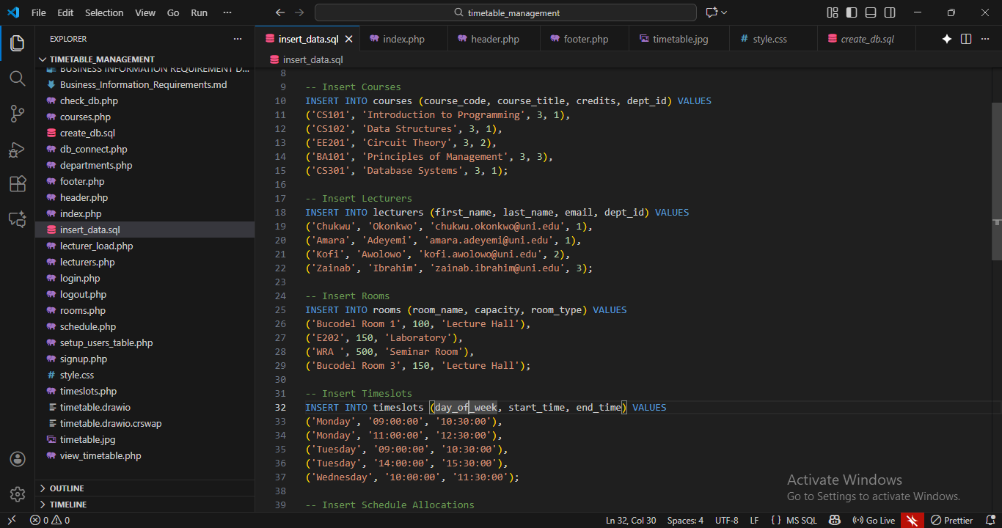
(insert_data.sql)

Non-Functional Requirements
- Usability
- Intuitive UI with navigation (header.php, footer.php)
- Clear forms for inserting data
- Mobile responsiveness (style.css base)

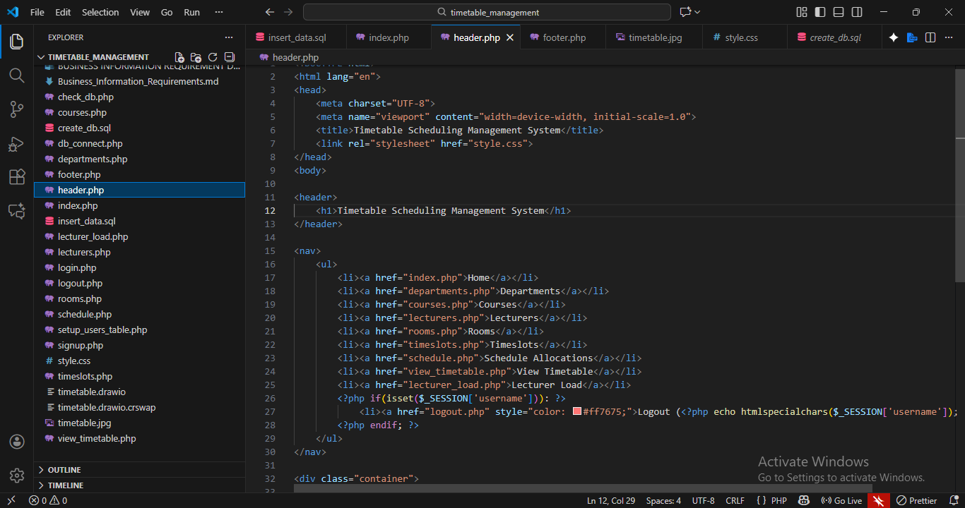
(header.php)

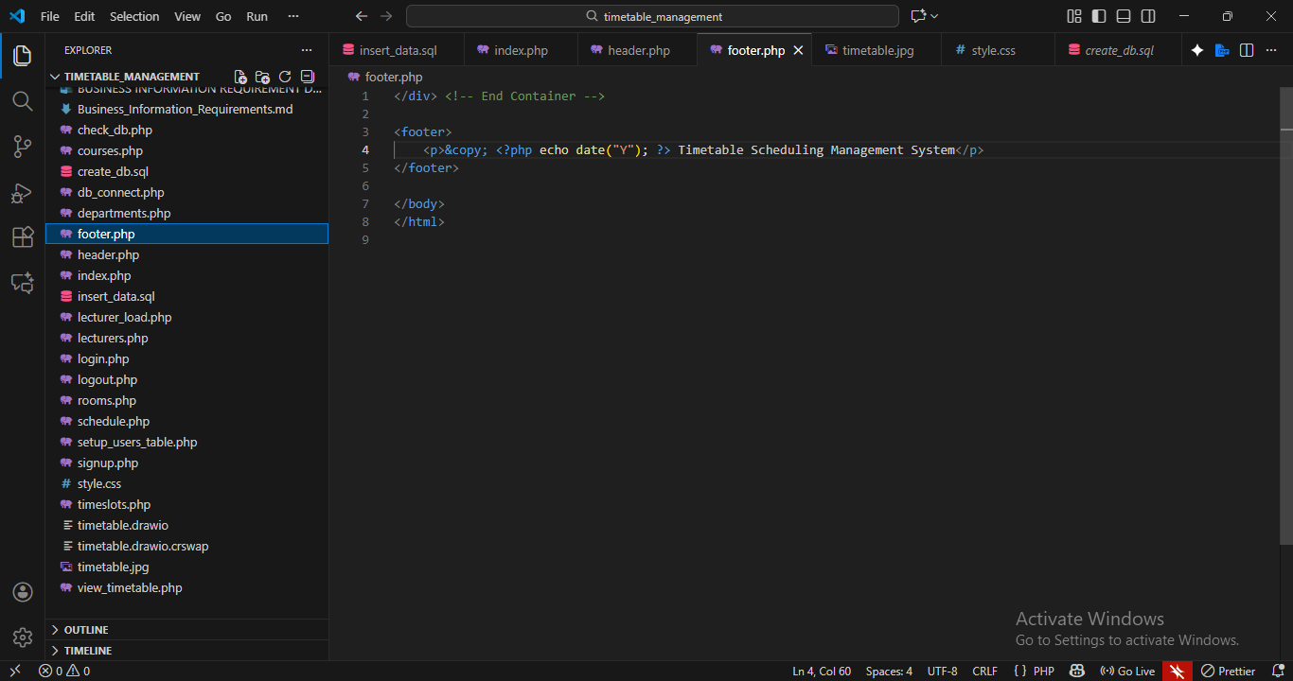
(footer.php)

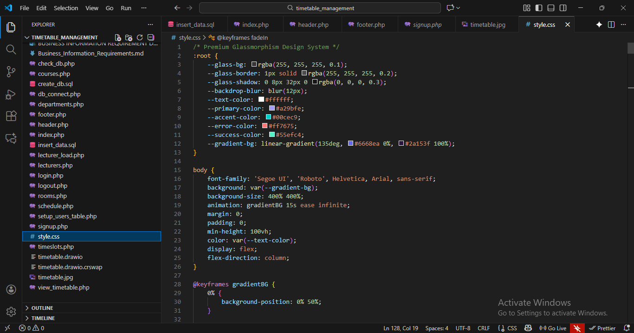
(style.css)

- Reliability
- Must prevent timetable conflicts using server-side validation
- Should ensure consistent data accuracy across all modules

3. Performance
- Fast database queries (PDO)
- Optimized viewing of weekly timetable

4. Security
- Input validation to prevent SQL injection (PDO prepared statements).
- Session-based authentication.

5. Scalability
- Should support multiple departments, lecturers, and rooms.
- Database normalization supports future expansion

Data Requirements
Entities & Relationships:
- Users → Home(1:M)
- Departments → Courses (1:M)
- Courses→ Schedule (1:M)
- Lecturers → Schedule (1:M)
- Rooms → Schedule (1:M)
- Timeslots → Schedule (1:M)
- Timetable (this table links all entities together)

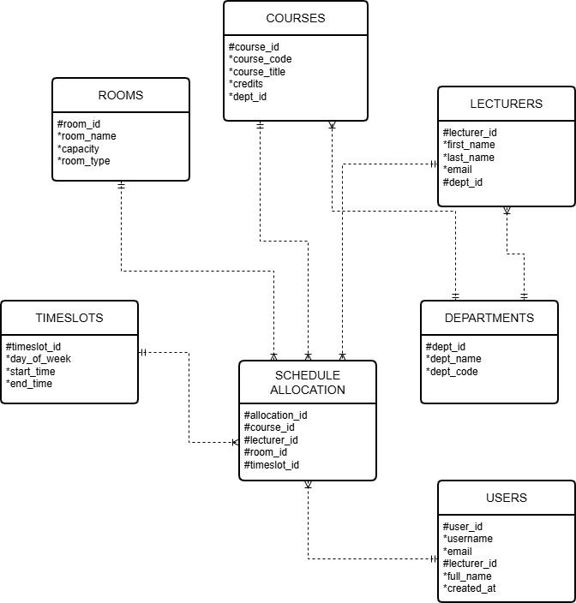
( Timetable Scheduling Management System ERD)

Policies:
- Consistent data
- Referential integrity
Business Rules
- A lecturer cannot teach two classes at the same time
- A room cannot host two classes simultaneously
- Each timetable entry must have:
- A valid department
- A valid course
- A valid lecturer
- A valid room
- A valid timeslot
- Only authenticated users can create or edit timetables
- Students can only view timetables; they cannot modify data.
- All timetable updates must be reflected immediately.

Information Outputs
The system must be able to generate:
- Department timetable
- Lecturer timetable
- Full weekly timetable
- List of courses per department
- Lecturer teaching loads
- List of rooms and availability

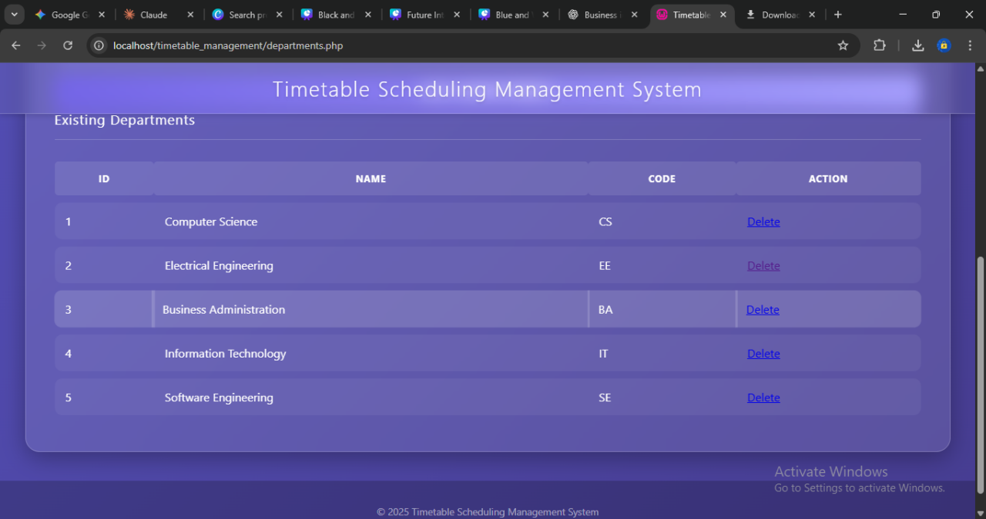
(department timetable)

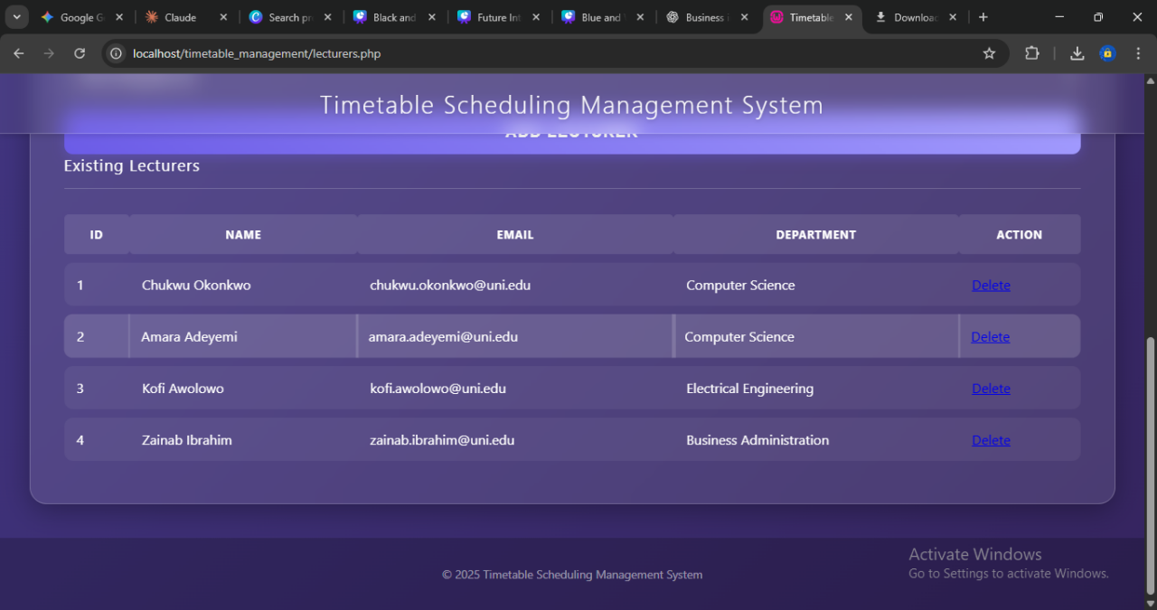
(lecturer timetable)

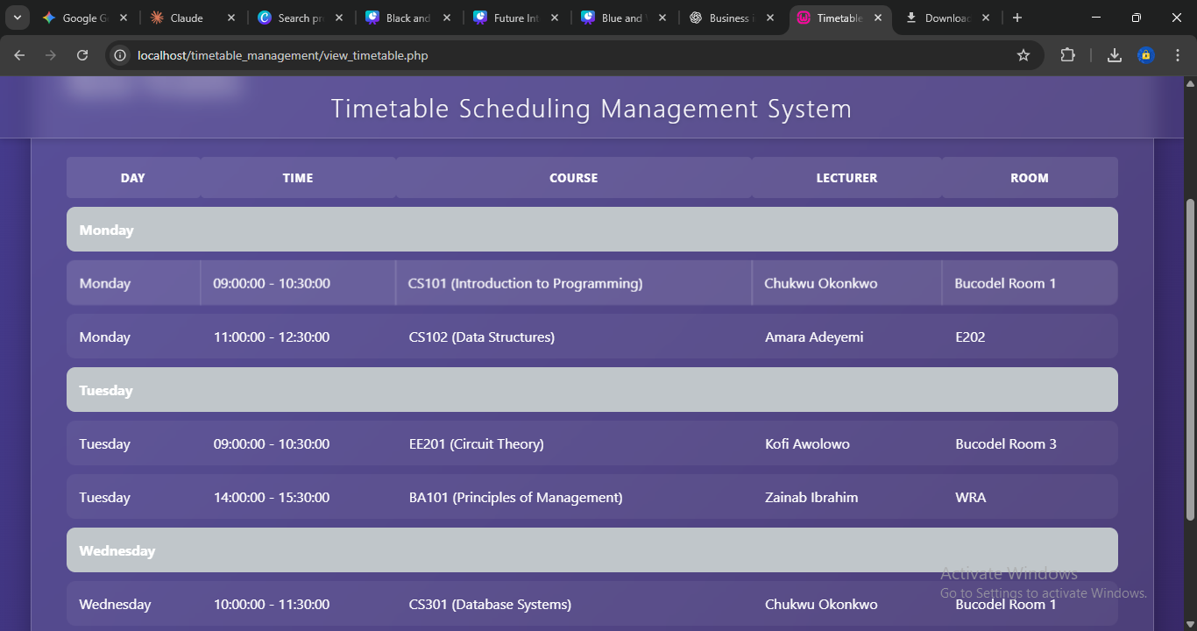
(the full weekly timetable)

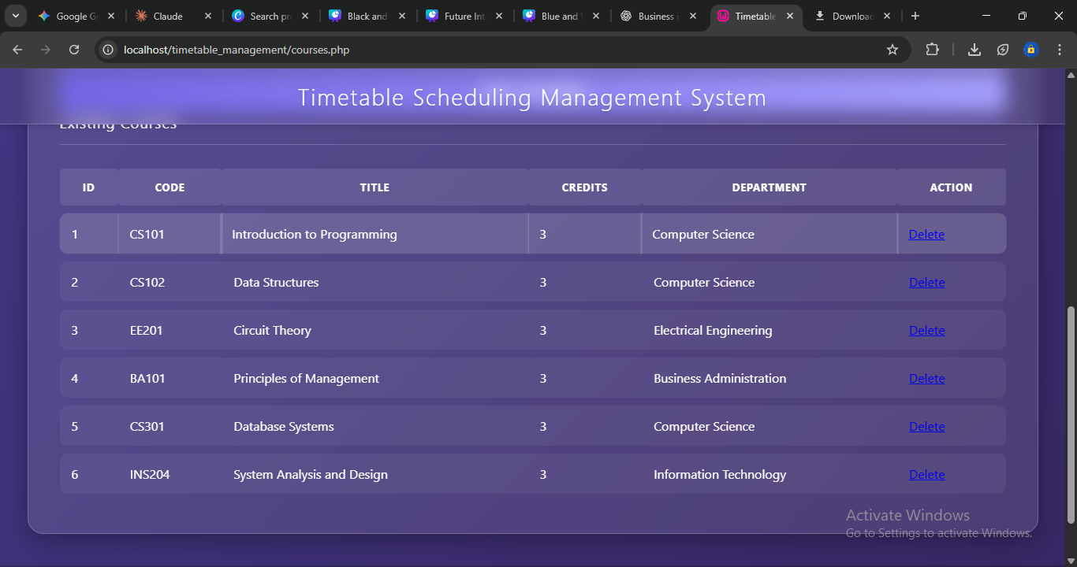
(list of courses per department)

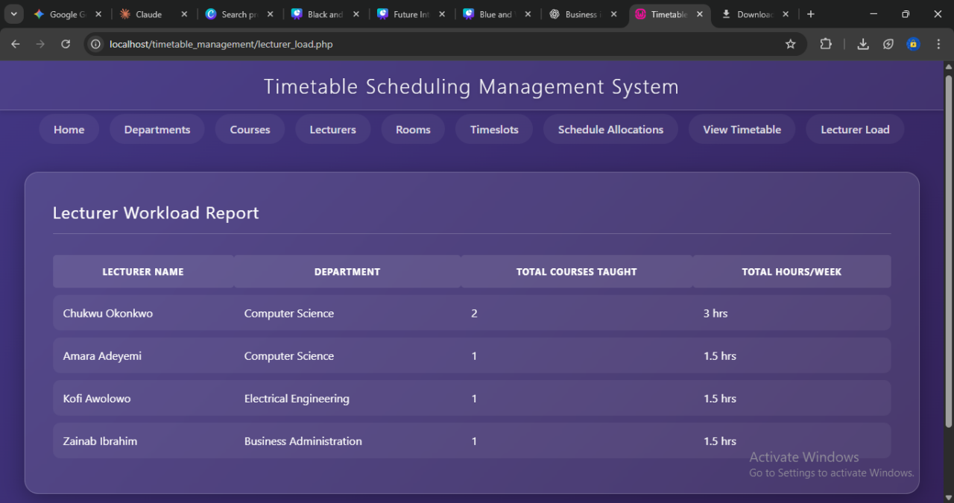
(the lecturers load)

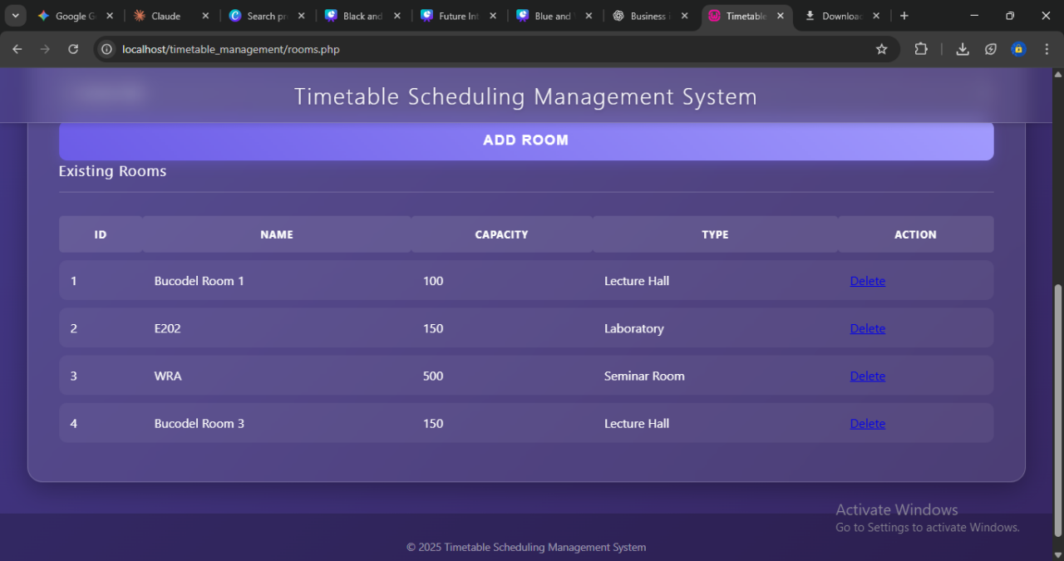
(the list of rooms available)

User Requirements
User Personas:
Admin, Student, Lecturer
User Stories:
Admins manage data; students view timetable.
Interface:
Simple CRUD forms, readable timetable view.
Training:
Minimal required.
Integration Requirements
- Internal integration through db_connect.php
- No external API integrations
Success Criteria
- Accurate timetable
- CRUD functions work fully
- Authentication successful
KPIs:
- Page loading time
- Conflict error rate
Acceptance:
- All modules functional
- Data stored correctly
Constraints & Assumptions
Constraints:
- PHP & MySQL
- Requires local server
Assumptions:
- Valid user credentials
- Database exists before use
Risks and Mitigation
Duplicate scheduling → conflict checks
Weak password storage → implement hashing
SQL injection → use prepared statements
Data errors → form validation
Downtime → backups

